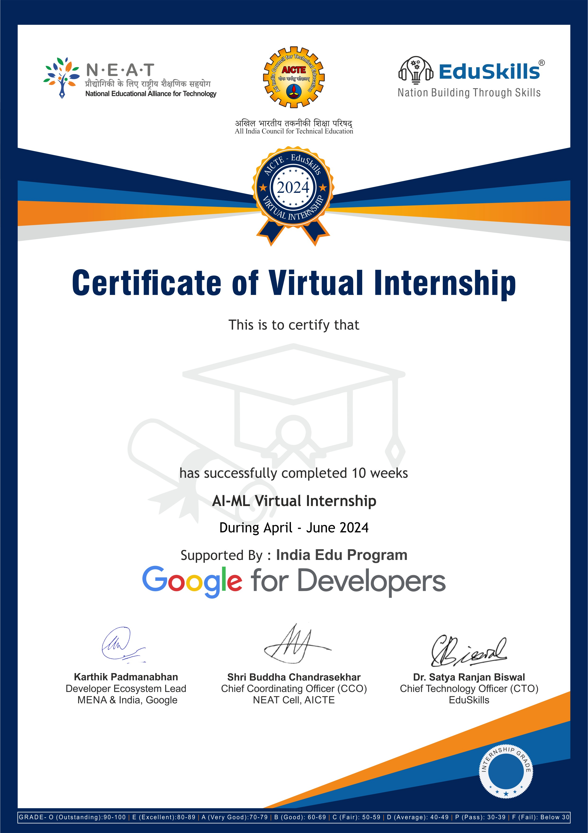

NARALASETTI DURGA LAKSHMI
Ideal Institute of Technology
Certificate ID :5a90351ab55f8e5f627c937184351d7a
Student ID :STU64e5e8f5e3d8a1692788981
B

